LetsUpgrade AWS Essentials Assignment

**Project 3**

**Create 2 Linux Instance, Install http service in both instance**

**Create Elastic Load Balancer and assign these 2 Linux servers, Test the ELB**

**Linux 1 Instance**

1. Public DNS: ec2-3-131-90-145.us-east-2.compute.amazonaws.com
2. Public IP: 3.131.90.145

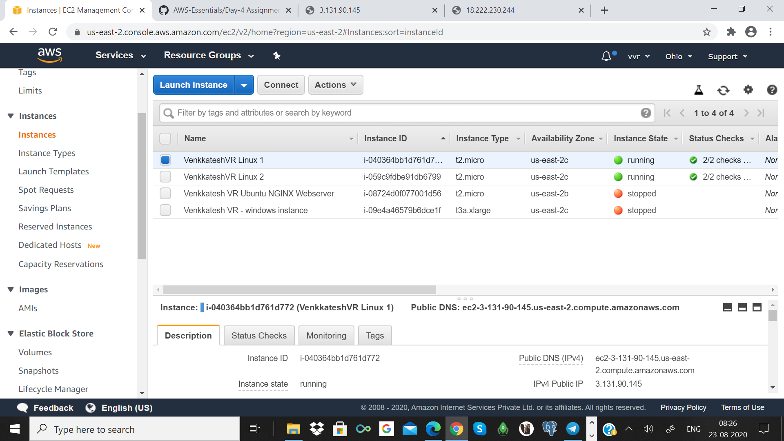

**Linux 2 Instance**

Public DNS: ec2-18-222-230-244.us-east-2.compute.amazonaws.com

Public IP: 18.222.230.244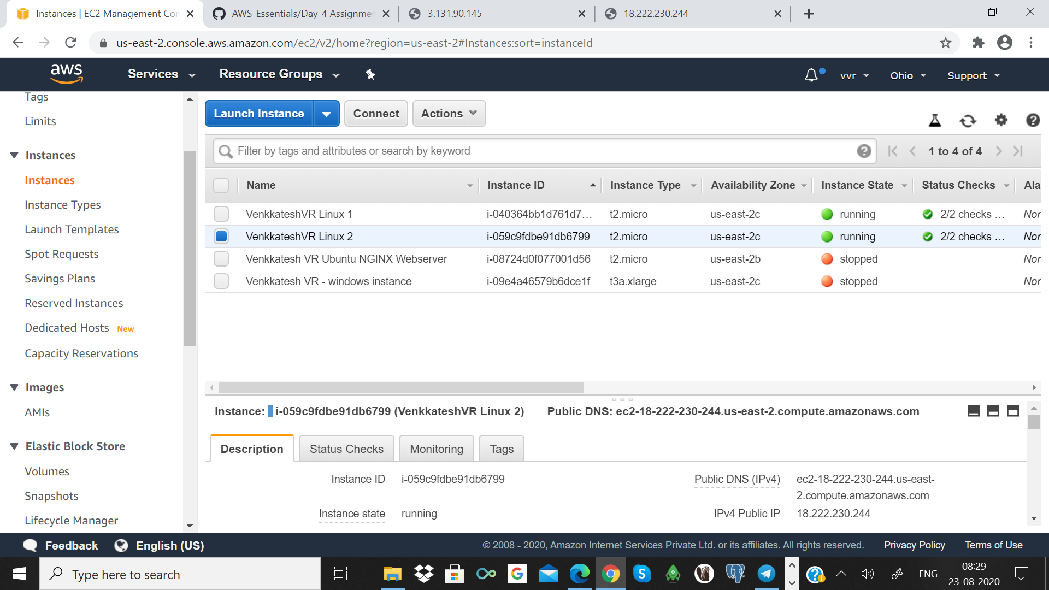

ELB

Public DNS: VenkkateshVR-ELB-1767524479.us-east-2.elb.amazonaws.com

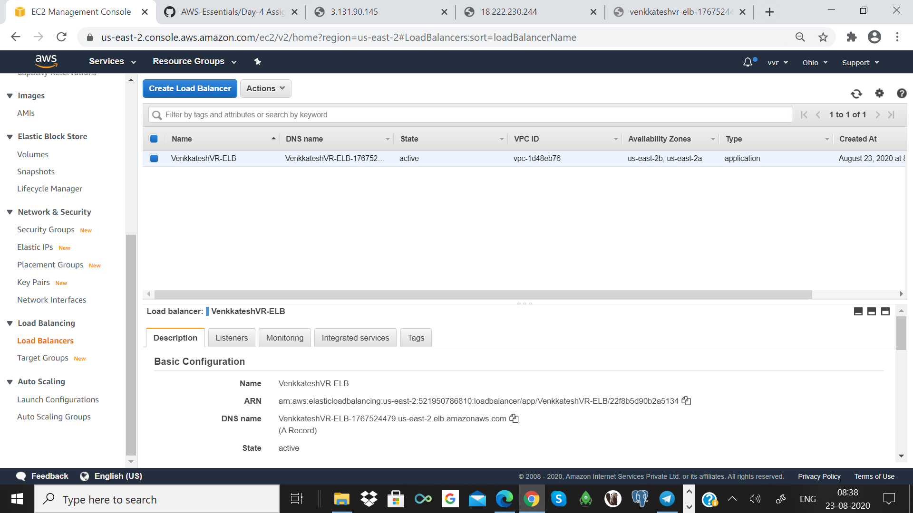

ELB Target Groups

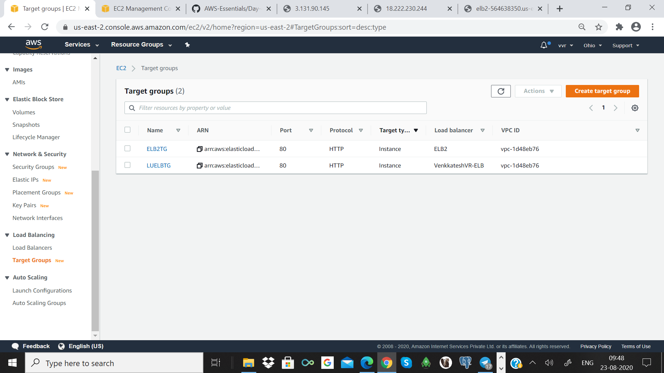

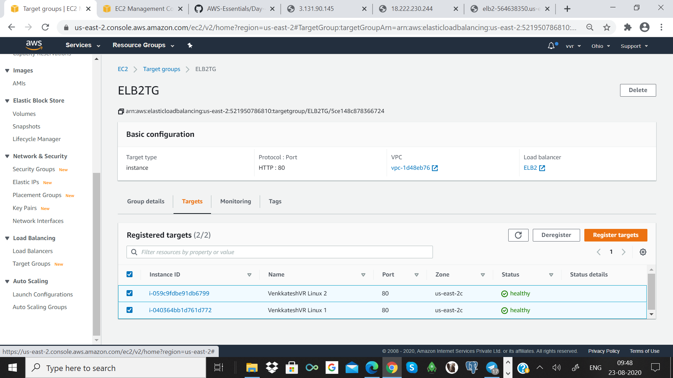

**Accessing Instance 1 via ELB**

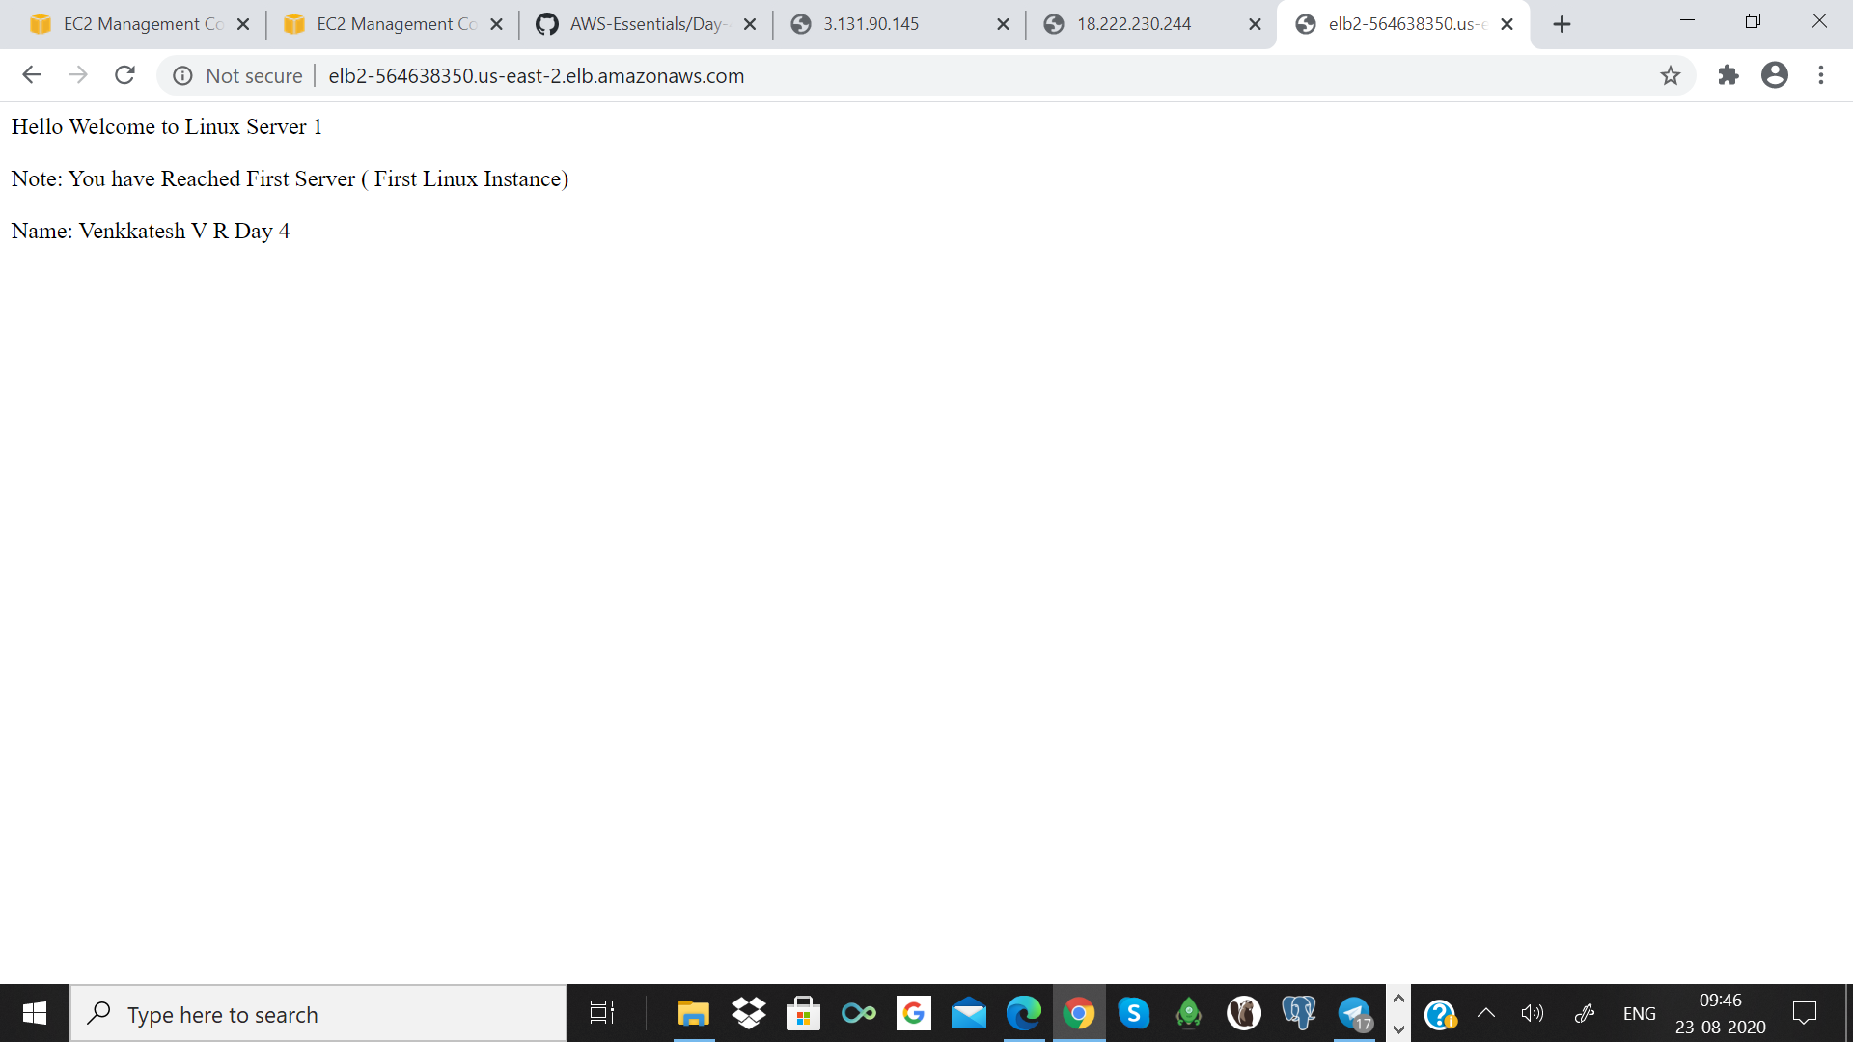

**Accessing Instance 2 via ELB**

